Project Planning Phase
Project Planning (Product Backlog, Sprint Planning, Stories, Story points)

Date | 15 July 2026
Team ID
Project Name | Food Ordering Behaviour and Consumer Trends
Maximum Marks | 5 Marks

Product Backlog, Sprint Schedule, and Estimation (4 Marks)
Use the below template to create product backlog and sprint schedule
Sprint | Functional Requirement (Epic) | User Story Number | User Story / Task | Story Points | Priority | Team Members
Sprint-1 | Data Collection | USN-1 | As a Business Analyst, I want to collect the food ordering dataset so that analysis can begin. | 3 | High
Sprint-1 | Data Preparation | USN-2 | As a Business Analyst, I want to clean missing and duplicate records so the dataset is accurate. | 2 | High
Sprint-1 | Tableau Connection | USN-3 | As a Business Analyst, I want to connect the dataset to Tableau for visualization. | 2 | High
Sprint-2 | KPI Dashboard | USN-4 | As a Business Analyst, I want KPI cards showing total orders, revenue and delivery fee. | 3 | High
Sprint-2 | Cuisine Analysis | USN-5 | As a Business Analyst, I want to analyse cuisine preferences across cities. | 3 | Medium
Sprint-3 | Customer Behaviour | USN-6 | As a Business Analyst, I want to analyse meal type and customer ordering behaviour. | 3 | High
Sprint-3 | Delivery Analysis | USN-7 | As an Operations Manager, I want to analyse delivery time distribution. | 2 | High
Sprint-4 | Dashboard Publishing | USN-8 | As a stakeholder, I want the dashboard published on Tableau Public. | 2 | Medium
Sprint-4 | Flask Integration | USN-9 | As a stakeholder, I want the dashboard embedded in a Flask application. | 3 | Medium
Sprint-4 | Documentation | USN-10 | As a project team member, I want to prepare the project report and demonstration. | 2 | High

Project Tracker, Velocity & Burndown Chart: (4 Marks)
Sprint | Total Story Points | Duration | Sprint Start Date | Sprint End Date (Planned) | Story Points Completed (as on Planned End Date) | Sprint Release Date (Actual)
Sprint-1 | 10 | 6 Days | 23 June 2026 | 28 June 2026 | 10 | 28 June 2026
Sprint-2 | 10 | 6 Days | 30 June 2026 | 05 July 2026 | 10 | 05 July 2026
Sprint-3 | 10 | 6 Days | 07 July 2026 | 12 July 2026 | 10 | 12 July 2026
Sprint-4 | 10 | 6 Days | 13 July 2026 | 13 July 2026 | 10 | 14 July 2026

Velocity:
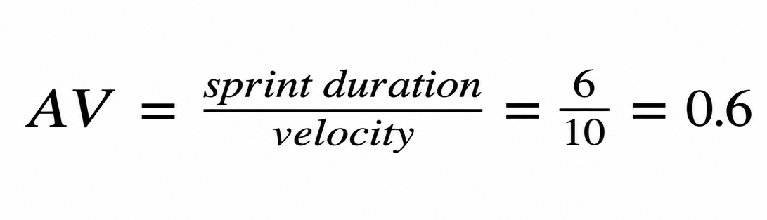

Burndown Chart:
A burn down chart is a graphical representation of work left to do versus time. It is often used in agile software development methodologies such as Scrum. However, burn down charts can be applied to any project containing measurable progress over time.

Day | Remaining Story Points
0 | 40
1 | 36
2 | 31
3 | 25
4 | 20
5 | 15
6 | 10
7 | 6
8 | 3
9 | 0

https://www.visual-paradigm.com/scrum/scrum-burndown-chart/
https://www.atlassian.com/agile/tutorials/burndown-charts
Reference:
https://www.atlassian.com/agile/project-management
https://www.atlassian.com/agile/tutorials/how-to-do-scrum-with-jira-software
https://www.atlassian.com/agile/tutorials/epics
https://www.atlassian.com/agile/tutorials/sprints
https://www.atlassian.com/agile/project-management/estimation
https://www.atlassian.com/agile/tutorials/burndown-charts

